«___»__________ 2015 г.

КОДИРОВАНИЕ ГРАФИЧЕСКОЙ ИНФОРМАЦИИ. ПАЛИТРЫ ЦВЕТОВ

Повторение

|  |  |
| --- | --- |
| 1. | Чему равен 1 байт? |
| 2. | Во сколько раз 1 Мбайт больше 1 Кбайта? |
| 3. | Сколько байт в1 Кбайте? |
| 4. | Расположите в порядке возрастания:  А) 1 Гбайт Б) 1 Кбайт В) 1000 байт Г) 10 Мбайт |
| 5. | Сколько бит в10 байтах? |
| 6. | Расположи в порядке убывания:  А) 1 Гбайт  Б) 1Кбайт В) 1 бит Г) 1 байт Д) 1 Мбайт |

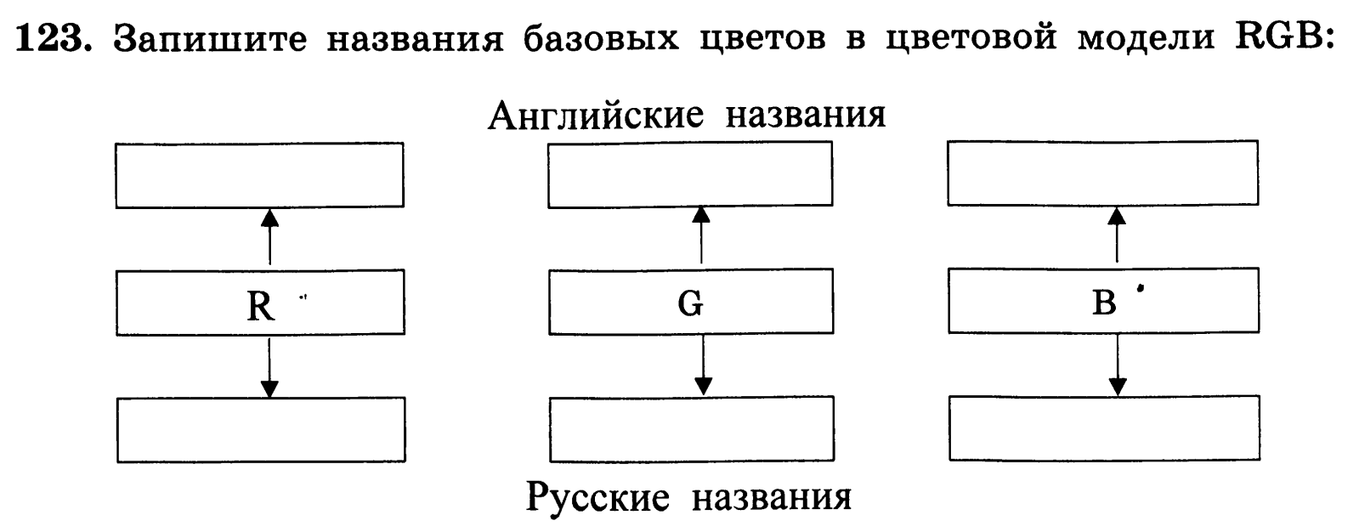

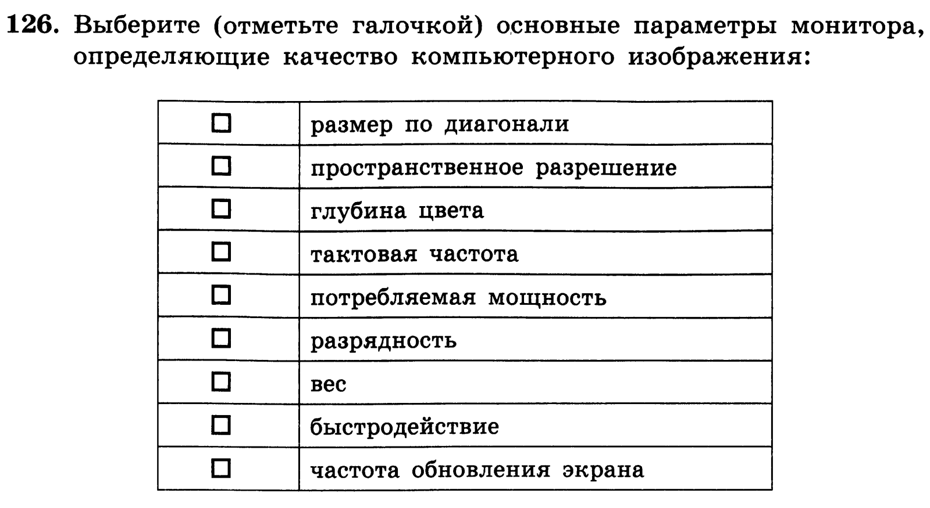

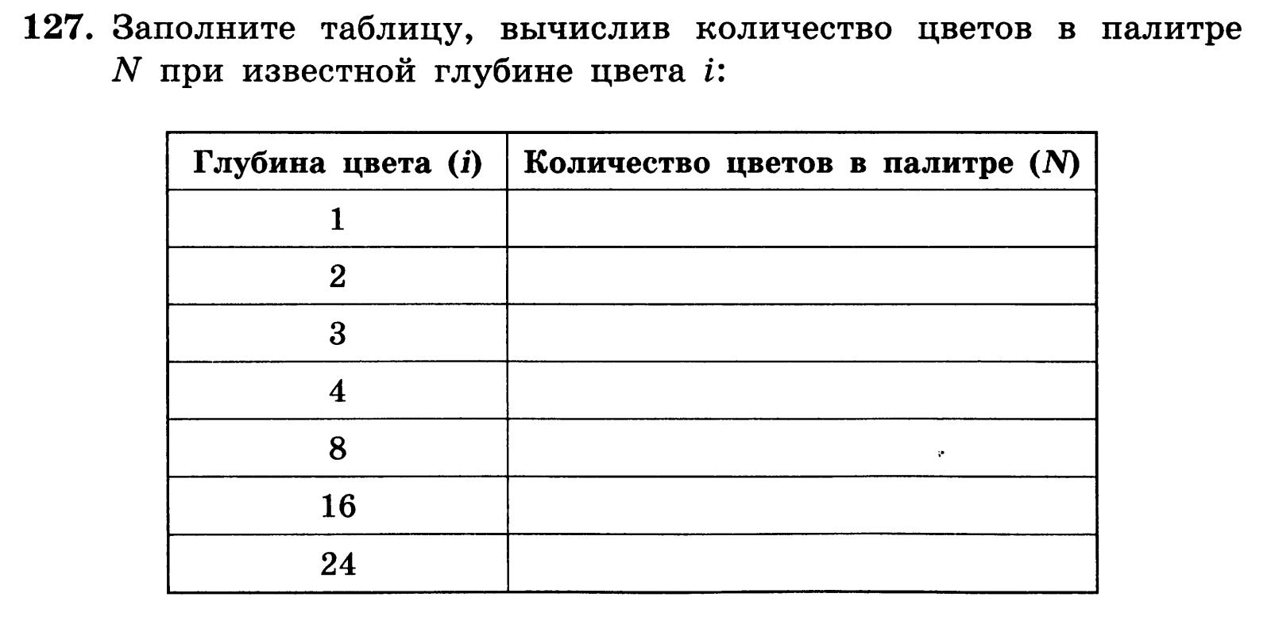

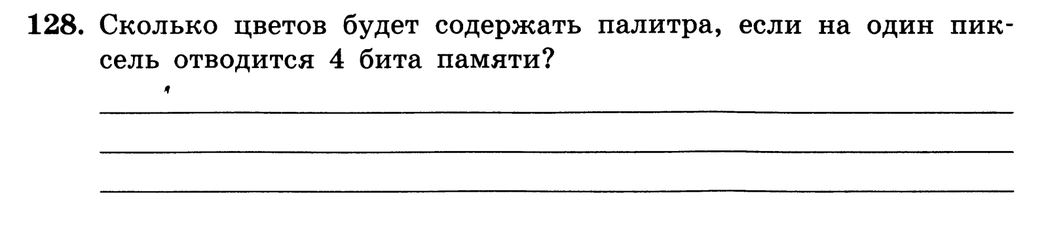



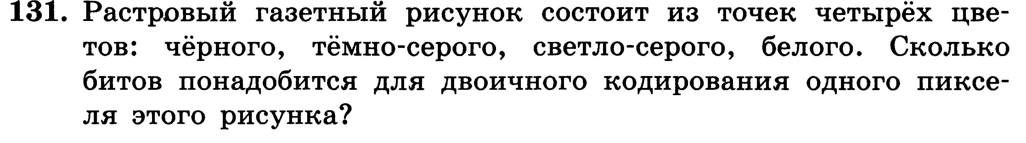



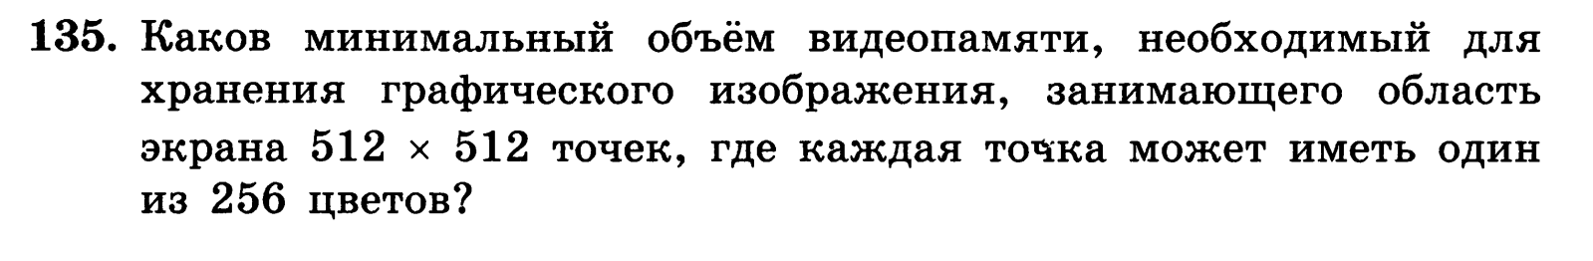

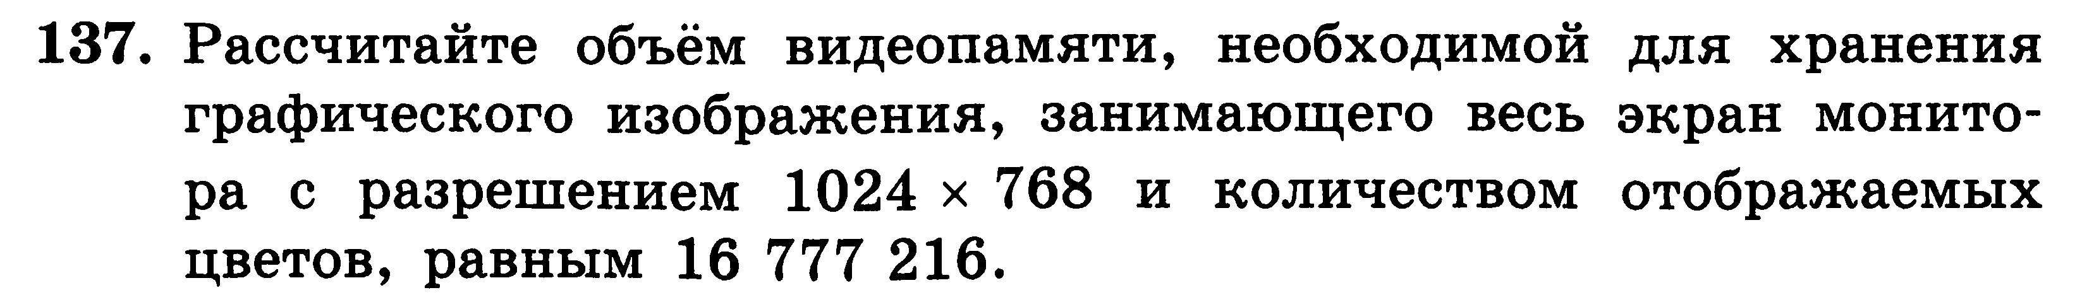

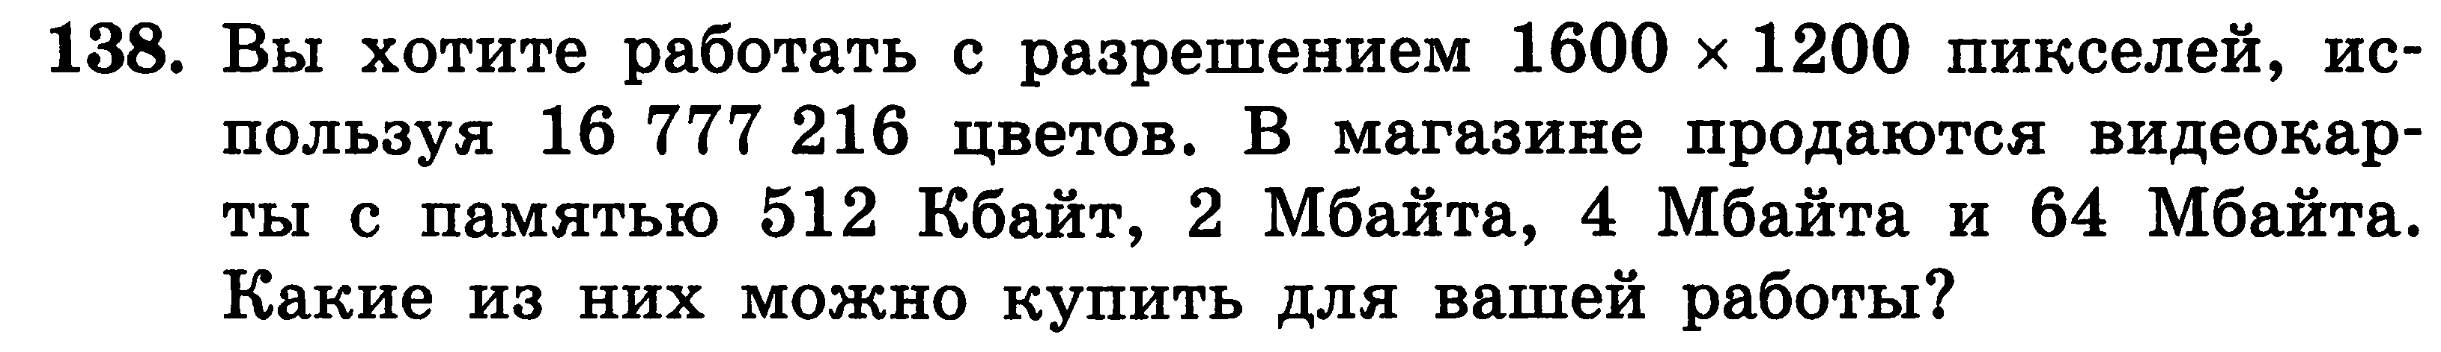

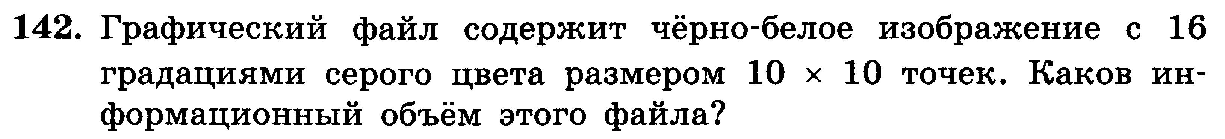



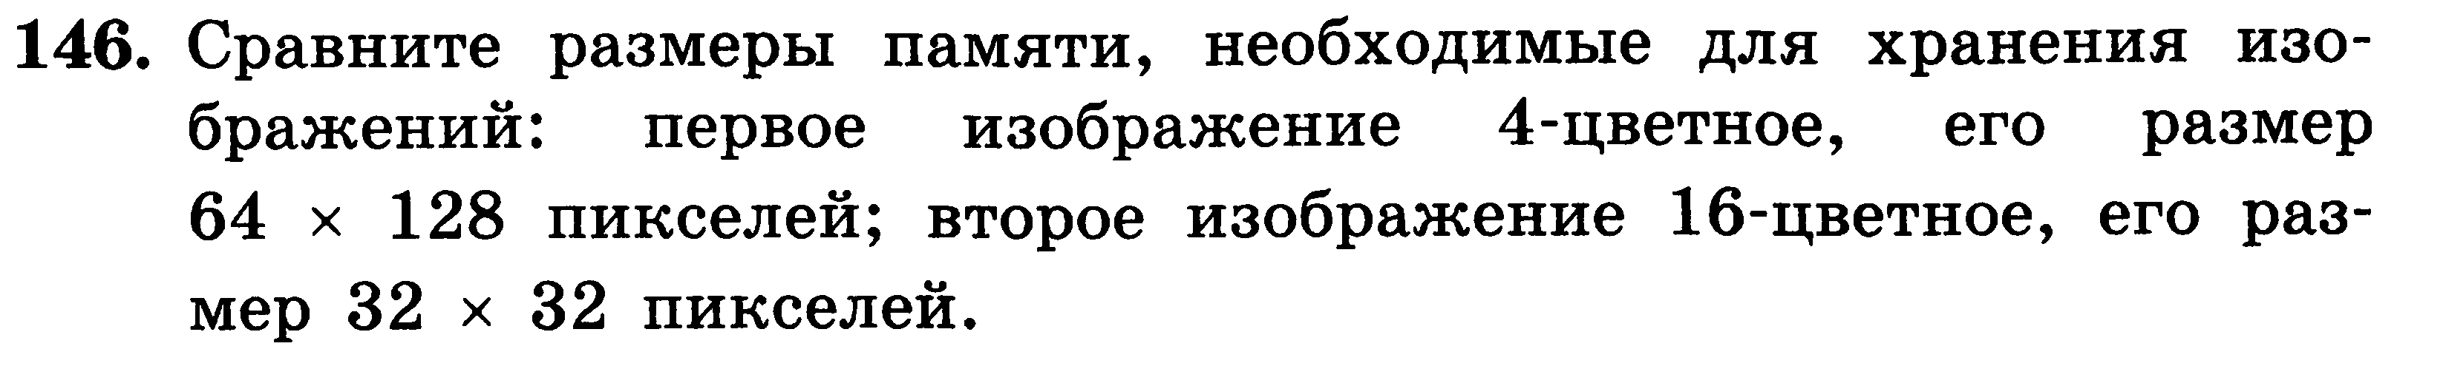

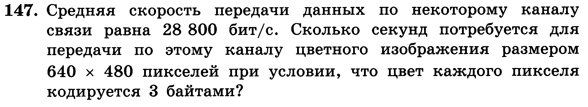

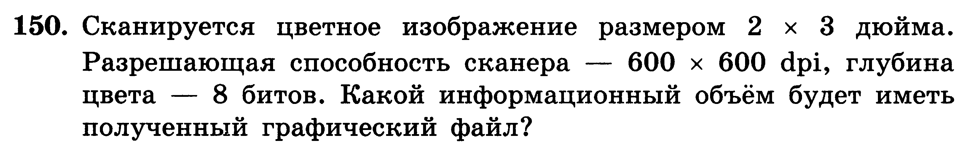

ДОМАШНЕЕ ЗАДАНИЕ













